INFO 6205

Data Structures and Algorithms

Homework8

April 20, 2022

1. Consider the following string: “ABDCCEDDFCABBCCEFDDAAFF”

a) What is R value?

b) Use key-indexed counting sort algorithm to sort the string. Show each steps

and the results.

c) What is the running time complexity of the algorithm as compared to Heap sort?

d) Write the java code to sort the string using steps described in (a)

2. The following Ford-Fulkerson network Flow graph problem shows 2nd iteration of the original graph. Show the remaining iterations step-by-step algorithm including data structures and augmented-paths to find Maximum Flow from source A to destination G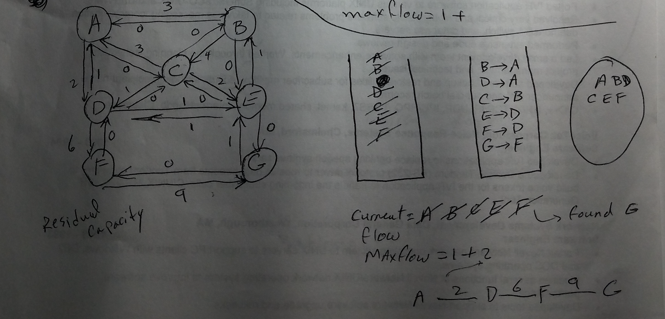

3. Consider the following graph. A) Find the shortest-path from source vertex A to any destination vertex on the graph. Show the data structures and step-by-step algorithm to find solutions presented in data structures. B) Explain how to use Path-map data structure to find path from A to any other destination.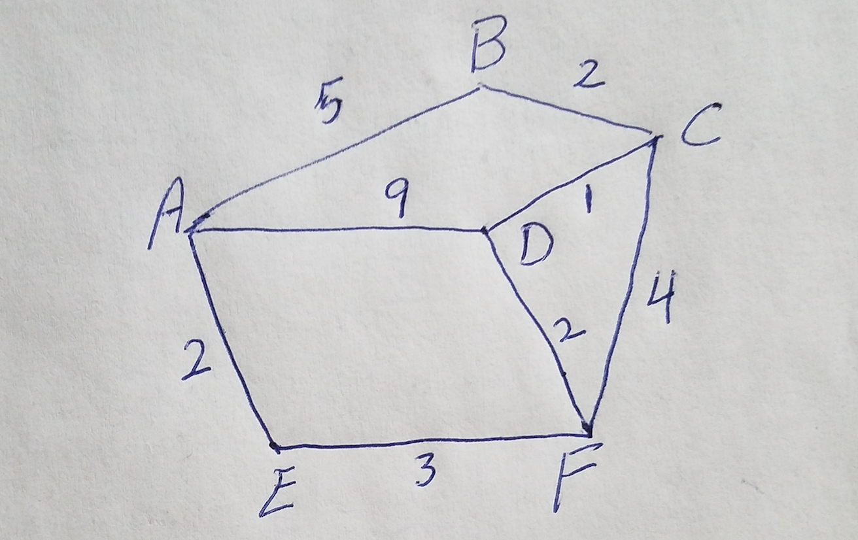

4. Consider Ford-Fulkerson Algorithm:

Explain step-by-step of how the algorithm works. Is there a recursive nature

to this algorithm? What is its termination point?

Begin

   initially mark all nodes as unvisited

   state of start as visited

   predecessor of start node is φ

   insert start into the queue qu

   while qu is not empty, do

      delete element from queue and set to vertex u

      for all vertices i, in the residual graph, do

         if u and i are connected, and i is unvisited, then

            add vertex i into the queue

            predecessor of i is u

            mark i as visited

      done

   done

   return true if state of sink vertex is visited

End

5. Consider the following graph. A) Find the shortest-path from source vertex A to any destination vertex on the graph. Show the data structures and step-by-step algorithm to find solutions presented in data structures. B) Explain how to use Path-map data structure to find path from A to any other destination.

6. Consider the following graph. Find Minimum Spanning Tree sub-graph of the graph using Kruscal’s algorithm. A) Explain data structures showing step-by-step algorithm to find the final solution presented in data structures. Note: Edge AB=3, AD=1, DC=1, BD=3, BC = 1; CE=5; CF=4, DE=6, FE=2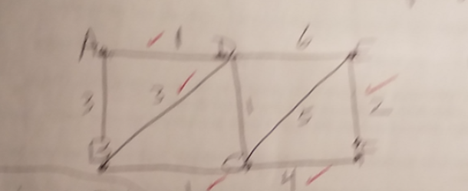

7. Consider the following graph. Find Minimum Spanning Tree sub-graph of the graph using Prim’s algorithm. A) Explain data structures showing step-by-step algorithm to find the final solution presented in data structures. B) How to use Edge-table data structure to show the solution for minimum spanning tree, C) How many Spanning Tree sub-graphs can you identify in the graph?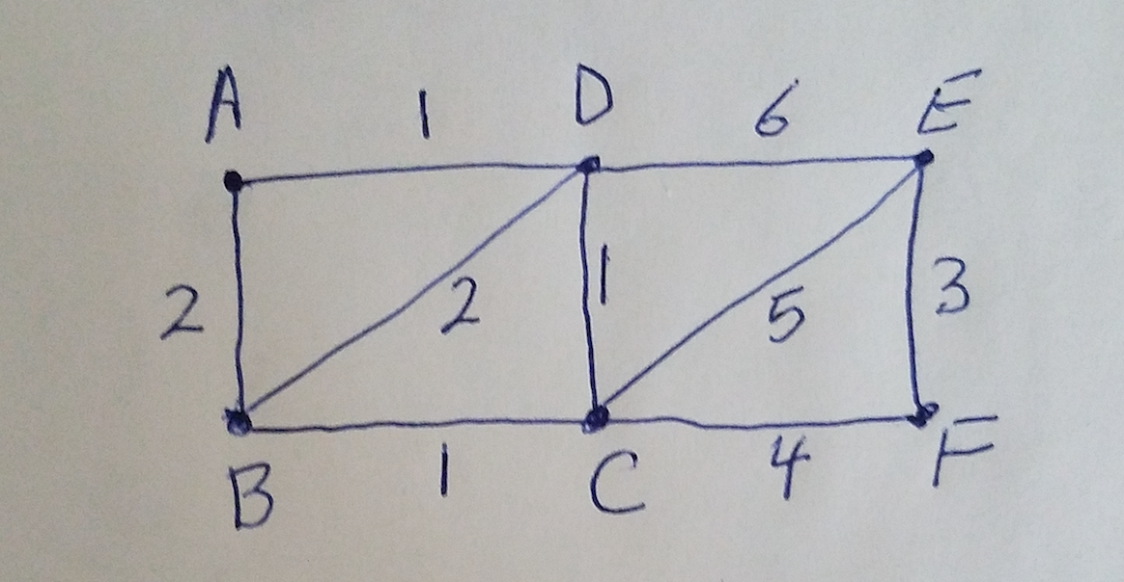

8. Solve Shortest path of this graph using Bellman-Ford algorithm, step-by-step with

Relaxation function.pasted-image.tiff

9. Consider the following bellman-ford graph

A) solve for shortest-path

B) A negative “cycle” makes the path shorter and shorter: Does this graph has

negative cycle? Yes/No explain

What does that mean? How to test for negative cycle?

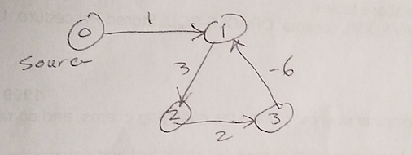

10. Identify each of these algorithms, Explain in details

A)

1. Make a queue (Q) with all the vertices of G (V);

2. For each member of Q set the priority to INFINITY;

3. Only for the starting vertex (s) set the priority to 0;

4. The parent of (s) should be NULL;

5. While Q isn’t empty

6. Get the minimum from Q – let’s say (u); (priority queue);

7. For each adjacent vertex to (v) to (u)

8. If (v) is in Q and weight of (u, v) < priority of (v) then

9. The parent of (v) is set to be (u)

10. The priority of (v) is the weight of (u, v)

B)

1. T is defined to be the empty set;

2. For each vertex v of G, make the empty set out of v;

3. Sort the edges of G in ascending (non-decreasing) order;

4. For each edge (u, v) from the sorted list of step 3.

If u and v belong to different sets

Add (u,v) to T;

Get together u and v in one single set;

5. Return T

C)

1. Sort G into L;

2. Set the distance to the source to 0;

3. Set the distances to all other vertices to infinity;

4. For each vertex u in L

5. - Walk through all neighbors v of u;

6. - If dist(v) > dist(u) + w(u, v)

7. - Set dist(v) <- dist(u) + w(u, v);